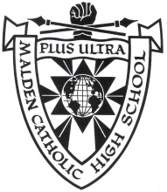

MALDEN CATHOLIC HIGH SCHOOL
99 Crystal Street
Malden, Massachusetts, USA 02148
www.maldencatholic.org

Following is the list of approved agencies/consulting firms currently working with Malden Catholic High School on behalf of international students:

American International Student Service Center (AISSC)
Contact Person: Will Yan
Willy@useduaissc.org
(Cell): 646-318-6817
(Office): 617-301-5058
http://www.useduaissc.org/

EduBoston
http://www.eduboston.com

IP Education
Contact Person: Sal Mihoubi
Mailing address: 1 Mifflin Place Suite 400, Cambridge MA 02138
617 999 9399
Website: www.ip-education.com

Ivy Bridge Group
Admissions Department
admissions@ivybridgegroup.com
888-424-4613
www.ivybridgegroup.com

Ivy International Group
www.usivy.net

United Edu Steward & Solutions, Inc. (UESS)
Contact Person: Vivian Yang (Chinese name: Yang Xinxia)
vivian.yang@uess.cn
US: 857-210 4767/ China: 010-53518789
http://uess.cn/

